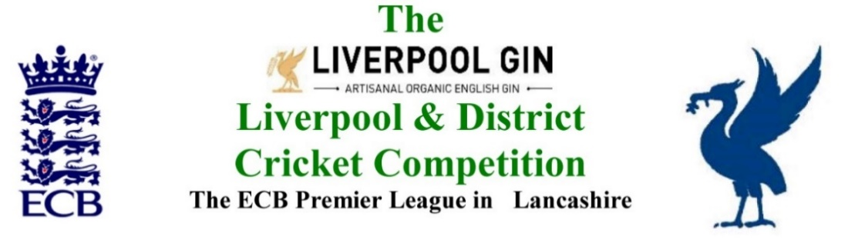
www.lpoolcomp.co.uk

M/C Meeting held at Bootle CC on Monday 30th October 2017 at 1.00pm:

Agenda item | Recorded Minutes
1.  Apologies:  12.58pm | - All members of M/C were present these being:  Eric Hadfield (President) John Williams (Chair) Chris Weston (Hon Sec); Rob Durand (1st & 2nd Team Fixture Secretary); Alan Bristow (Hon Treas); John Rotheram (Cricket Chair); Eddie Shiff (3rd XI Coordinator).
2.  Minutes: | - Signing of Previous Meetings  The Chair (JW) signed the minutes as a true and accurate record of the meeting held on 25th September 2017.  - Action Point Items  These were considered as set out below.  - Matters arising  These were to be taken en passant as they were covered by agenda items.  2.4 Cup Draws  The four 1st and 2nd XI Cup Draws would be drawn at this meeting.
3. Chairman's Remarks | - Premier Leagues meeting  5-8pm Old Trafford Monday 6th November 2017  5 Premier Cricket Leagues (PCLs) in our group:  Cheshire/L&DCC/Northern/North Staffs & South Cheshire/North Wales.  We would go to the meeting prepared, we had a good story to tell at several levels particularly over the link between the professional game and the recreational. Detailed examples were given. The pressures exerted by the “battle” between Elite cricket and Mass Participation cricket was the key. ECB seemed to be swinging very much towards the latter.  - LCB/LCF changes  LCB became LCF on 01/11/17. JW outlined the process factually.  http://www.lccc.co.uk/cricket/news/2017-news/lancashire-county-cricket-club-confirm-new-appointments-and-structure/  - End of Season meeting 06/10/17 outcomes  3.3.1 Replies  There had been one reply over Dual Registration wanting it to be extended and made more accessible. There had been no other outcomes.  3.3.2 New Laws  Law 42 New Law On field Sanctions 1-4 were discussed. They needed very careful use. We would follow ECB’s likely steer to premier leagues on their use in 2018.  ECB had used these on-field sanctions in 2016 and 2017 in their National Competitions. There had been no problems. Cheshire were part of the 2017 trial and had not reported difficulties.  - 3rd XI Meeting Draft Agenda  3.4.1 Agenda  The agenda was discussed and agreed.  3.4.2 3rd XI fixtures 2018  The duplicated summary from EH for the meeting was discussed.  - Rearrangement of Digman Cup 2017 to 2018 update  The semi-final Bootle v Ormskirk was 15/04/18 but might be switched to 7th or the 8th /04/18 if both clubs agreed. The Final was on 29/04/18 Northern v ?  - Fixtures 2018 update, requests from clubs  9 or 10 had been received, M/C ran through some of these. M/C would put a reminder on the website and circ it by email.  - Deducting marks for SoC for Spirit 2017  The matter was discussed and adjustments agreed.
4.  Club & Ground Chair’s Report | - EH 2017 inspections update  There were 12 more clubs to visit in 2018,being:  Ainsdale/Colwyn Bay/Caldy /New Brighton /Highfield /Wallasey /Southport Trinity/ Skelmersdale/Sutton/Newton le Willows/ Rainford /Fleetwood Hesketh  - Letters to promoted clubs  M/C would be sending these.  - C&G stats and SoC stats publishing thereof?  Only seven 1st XI prem captains had sent in ECB reports, these were:  New Brighton/Lytham/Formby/Wallasey/S&B/Ormskirk and Colwyn Bay.  As usual AB had sent all prems a proforma in April and reminders in August and September.
5.  Hon Treasurer’s Report | - Figures of Account Sept/Oct  N/A - auditing  - Income and Expenditure Sept/Oct  N/A - auditing  - Auditing process 2017  5.3.1 The accounts had been submitted to the auditors on 19th Oct 2017. A loss of about £1,000 was expected.  The Hon Treas supplied M/C with copies of the latest bank accounts  5.3.2 Five clubs still owed money.  - Fines update  There were 5 queries out of 960 individual fines, this overall was felt to be of great credit to the systems.  - Ball sponsorship 2018 update  This had been completed and circulated  - Billy Smith support from L&DCC  A letter of thanks had been received.
6. Registration Sec's Report | - Registrations Report RD update  The Hon Reg Sec had removed 23 Cat 3 Not Exempts this week as per regulations and to force re-registrations in 2018.  Those players that have not played for their clubs four years or more i.e. not having played in seasons 2014 -2017 inclusive were reviewed with a view to possible changes in the future.  6.2 Registration procedures in 2018  The Hon Reg Sec did not request any changes for 2018.
7  Fixture Sec's Report | - 1st/2nd XI FS’ Report RD  - 3rd XIs League Coordinators Report  - 1st XI Ray Digman Cup  - 1st XI Ray Tyler Shield / Cup  - NatWest ECB T20  - 2nd XI Chester Cup  - 2nd XI Tittershill Shield/Cup  - Chrysalis Cup 2nd XI T20  - Mike Leddy Cup 3rd XI T40  - Embee Cup 3rd XI T20  - U16s/U21s  - MCC Date/Game venue 2018  The Hon Sec had circulated correspondence with the MCC, the date was changed to Tuesday August 7th 2018.  - Indoor League 2017/2018  - Rep games 2017 U12/14/18/21/All Age  - ECB/LCB U19sT20 2018  - Brighton/Sussex touring side 2018 July 2018  Sussex CCC was partially supporting the touring side.  The Hon Sec would circulate the correspondence
8.  Cricket Chair’s Report | - Annual Dinner 2017 review - 2018 format Appendix 5  - The Hon Sec had summarised the existing correspondence. A discussion followed.  Outcome  The L&DCC Annual Dinner format would be changed in 2018  A date for some sort of function next year was agreed as Friday 5th October 2018  The venue and format would be decided later.  - Supporting MCUA training 2018/New ACO training: Meeting with MCUA re support  See 3.3.2 above
9. Publicity & Sponsorship Chair’s Report | - Items not previously covered under Item 3  No report
10. Website matters | - Website Postings  Transfers on the website were being kept up to date and were attracting widespread interest.
11.  Hon Secretary’s Report | - Dates of meetings see also Appendix 1  3rd XI EoS SGM Tues Nov 7th Sefton Park 7.30pm  LCB MoU 3 Thur Nov 16th Old Trafford 2-4pm  M/C AGM papers Mon 20th Nov Bootle 1.00pm  Cr Co? Mon Nov 20th  M/C Tues Nov 28th Bootle 1.00pm  - LCB Rec report  Was as circulated by CW, the meeting had been mainly about the LCB/F KO Draw and introducing LCF personnel to the leagues.  - L&DCC LCB KO 2018 entries  The L&DCC entries had been made and circulated.  - MCUA umpires entries LCB KO 2018  Was in preparation
12.  LCB / ECB Issues | - Changes to LCB/LCF KO 2019  The proposed changes to LCF 2019 had been circulated by CW. A discussion followed. We would supprt  - LCB/LCF changes  See 3.2
13.  A.O.B. | - M/C noted the CricHQ situation, they had gone out of business. No new details were known. Clubs had lost data. TCS and its future was not known.  - M/C heard that Liverpool StH RUFC had had league points deducted on Saturday last for another disciplinary offence by one of their players who had been sent off.
14.  Date of Next Meeting | See 11.1  M/C Tues Nov 28th 2017 Bootle 1.00pm et al  The meeting closed at 3.47 pm
15.  Cup Draws  2018 | The Draws for the Ray Digman Cup the Ray Tyler Shield the Chester Cup and the Tittershill Shield took place out-with the meeting

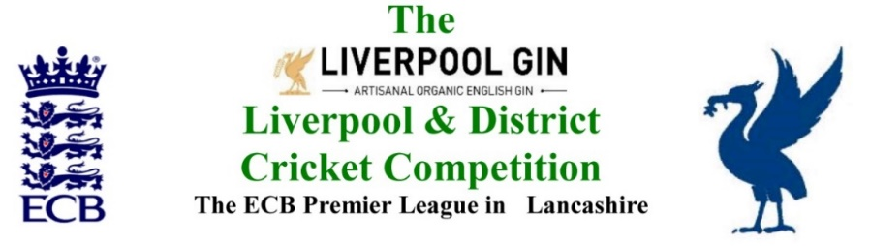
www.lpoolcomp.co.uk

The next meeting will be held at Bootle CC on Tuesday 28th November 2017 at 1.00pm.

DRAFT

Agenda to include

- Apologies

- Minutes

- Chairman's Remarks

- Club & Ground Chair’s Report

- Hon Treasurer’s Report

- Registration Sec's Report

- Fixture Sec's Report

- Cricket Chair’s Report

- Publicity & Sponsorship Chair’s Report

- Website matters

- Hon Secretary’s Report

- LCB / ECB Issues

- A.O.B.

- Date of Next Meetings

