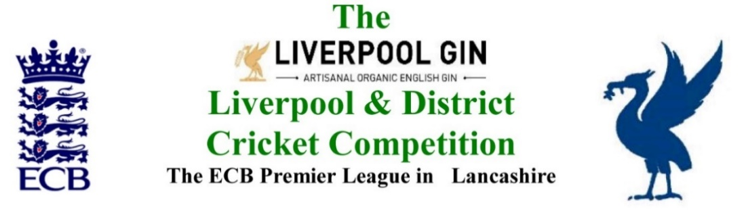
www.lpoolcomp.co.uk

M/C Meeting to be held at Bootle CC on Tuesday 28th Nov 2017 at 4.00pm:

Agenda item | Recorded Minutes
1.  Apologies:  4.07pm | - All members of M/C were present these being:  Eric Hadfield (President) John Williams (Chair) Chris Weston (Hon Sec); Rob Durand (1st & 2nd Team Fixture Secretary); Alan Bristow (Hon Treas); John Rotheram (Cricket Chair); Eddie Shiff (3rd XI Coordinator).
2.  Minutes: | - Signing of Previous Meetings  The Chair (JW) signed the minutes as a true and accurate record of the meeting held on 30th October 2017.  - Action Point Items  These were considered as set out below.  - Matters arising  These were to be taken en passant as they were covered by agenda items.
3. Chairman's Remarks | - Future of Premier Leagues P Bedford OT meeting outcomes  JW referred to the meeting he had attended 5-8pm Old Trafford Monday 6th November 2017.  JW ran through parts of the summary document  Discussion followed, JW led. Premier Leagues would continue, their amount of funding was debatable. There would be a model set of terms of operation.  - LCB/LCF changes update  JW noted that Clinton Perrin the new Director of the LCF was on holiday but an announcement on appointments was due “soon”.  - 3rd XI End of Season meeting 07/11/17 outcomes  The minutes had been released on the website, by e-circ and through Twitter without difficulty.  - Fixtures 2018 update, requests from clubs updates  http://www.lpoolcomp.co.uk/management_bulletins.php?id=2997 We were getting to the deadline of 30/11/17.  We had received a number of requests. EH had emailed all those clubs that had asked for changes last year and not requested same for 2018. The ECB fixtures were due. Our fixtures were in hand.  - Planning for AGM 2018  This would be taken later under item 11.1  - MCUA Meeting 30 11 17 Haydock  CW JW Hughie Evans Ray Rigby and Kevin Wilson were attending. The agenda for this meeting was largely based on a campaign to support the training at the new “Stages 1 and 2” of brand new umpires and perhaps separate sessions for player umpires – the “10 over umpires”.
4.  Club & Ground Chair’s Report | - EH 2017 inspections update  EH led, there was not much to say relative to the last meeting. The 12 clubs to be contacted in 2018 had been identified. No action was needed at the moment.  - Letters to promoted clubs  AB had sent out the 4 letters as promised, there had been one reply.  4.3 Reactions to Pitch Marks and SoC marks  A club had asked for more details of their pitch marks,
5.  Hon Treasurer’s Report | - Figures of Account Oct/Nov  Were given.  - Income and Expenditure Oct/Nov  All accounts were paid - except the auditors.  All debtors had paid..  - Auditing process 2017  AB noted that he had also received an email at about 3.00pm today from the auditors with the accounts for the year.  - Budget 2018  This would follow in due course.  - AGM 2018  AB would send CW the necessary reports for the AGM papers.  M/C thanked AB for a job well done.
6. Registration Sec's Report | - Registrations Report RD update  4 registration applications had been received  - SL Cricket Club  An email application had been received by CW and JW from a group wishing to set up a new club. The matter was discussed. They needed to get a ground and they needed to play some Sunday friendlies in 2017 to get started with the gaps created by the hoped for 4x7 Sunday structure. The matter was discussed, they needed to get a ground before they could join the 3rd XI structure.
7  Fixture Sec's Report | - 1st/2nd XI FS’ Report RD  RD reported that we had had 15 requests for fixture-consideration so far.  We needed the 1st class fixtures later this week before we could move properly.  - 3rd XIs League Coordinators Report  - 1st XI Ray Digman Cup  - 1st XI Ray Tyler Shield / Cup  - NatWest ECB T20  - 2nd XI Chester Cup  - 2nd XI Tittershill Shield/Cup  - Chrysalis Cup 2nd XI T20  - Mike Leddy Cup 3rd XI T40  We needed to remind clubs to make their entries for the 3rd XI cups - Embee and Leddy - in 2018 .  - Embee Cup 3rd XI T20  - U16s/U21s  There was to be no L&DCC U16/21s this year. The ECB/LCF U19s would run, it was important to LCF  - MCC Date/Game venue 2018  Indoor League 2017/2018  JW had this in hand, http://www.lpoolcomp.co.uk/management_bulletins.php?id=2995  - Rep games 2017 U12/14/18/21/All Age  - ECB/LCB U19sT20 2018  - Brighton/Sussex touring side 2018
8.  Cricket Chair’s Report | - Update: Annual Dinner 2018 format  This needed further debate.  - TCS update  Nothing further was known.
9. Publicity & Sponsorship Chair’s Report | - Items not previously covered under Item 3  No report
10. Website matters | - Gud Design for 2018  No report
11.  Hon Secretary’s Report | - Reports for AGM  - CW had made fair progress with the papers.  - CW would release the papers to the website on Sunday 17th December but would do so to M/C the week before for checking.  - Dates of meetings 2018  See Appendix 4  The basis of the dates was explained, the structure was similar to last year with shifts for the different length of the season, plus allowance for Bank Holidays.  - Posting of AGM papers  See 11.1.  - CW / Richard McCullagh  RMcC was to write a report for season 2017 and had consented to stand again in 2018.  - Irby CC 3rd XI release to CCL 2018  A letter had been sent by CW and copied round after M/C had been consulted. The matter was closed.  - Umpire survey circ  CW had been asked by ACO to circulate this to all clubs hopefully to “catch” occasional umpires.
12.  LCB / ECB Issues | - MoU update  This meeting was delayed in view of the LCF reorganisation.
13.  A.O.B. | 13.1 Cup Draws  EH would release these
14.  Date of Next Meeting  6.04pm | M/C Thur Dec 28th Bootle 1.00pm  AGM 2018 Tues Jan 16th Bootle 7.30pm

