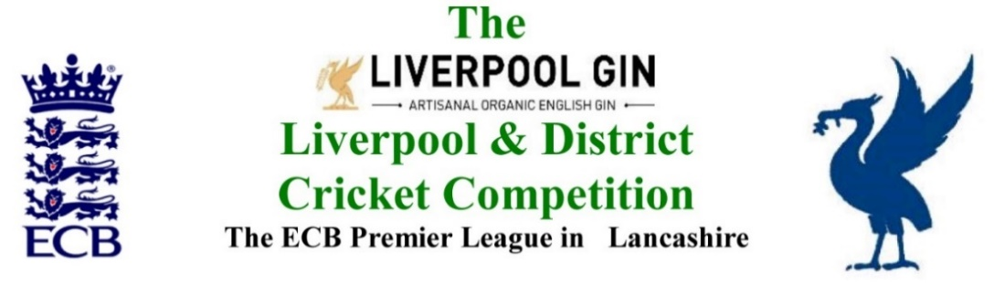
www.lpoolcomp.co.uk

There had been no single M/C meeting in July 2017

M/C Meeting held at Bootle CC on Tuesday 29th August 2017 at 1.00pm:

Agenda item | Recorded Minutes
Pre-meeting  1.  SP CC v  O CC  29 08 2017  5.30 pm | The matters were discussed in detail.  The clubs would be informed as would the umpires.
Pre-meeting  2.  O CC in ECB T45 Final 17 09 2017 | The matters were discussed in detail.  Ray Digman Trophy 2017 Summary:  Sunday 10 September Semi-Final  Bootle v Ormskirk 12.00 (Result required on the day)  If Bootle win the semi-final then the following applied:  Sunday 17 September Final  Bootle v Northern 11.30  If Ormskirk win the semi-final then the following applied:  Sunday 24 September Final  Northern v Ormskirk 11.30
The meeting then returned to the published agenda
1.  Apologies:  1.10pm | - All members of M/C were present being:  Eric Hadfield (President) John Williams (Chair) Chris Weston (Hon Sec); Rob Durand (1st & 2nd Team Fixture Secretary); Alan Bristow (Hon Treas); John Rotheram (Cricket Chair); Eddie Shiff (3rd XI Coordinator).
2.  Minutes: | - Signing of Previous Meetings  The Chair (JW) signed the minutes as a true and accurate record of the meeting held on 19th July 2017.  - Action Point Items  Were considered from the July meeting.  - Matters arising  These were to be taken en passant as they were covered by agenda items.
3. Chairman's Remarks | - Umpires C&G marks tranche 2 SoC if ABB  SoC marks were as published http://www.lpoolcomp.co.uk/notice_board.php?id=2924 ,  Discussion followed.  There was general agreement that the data on SoC was flawed, a wider perspective was needed i.e. other factors needed to be taken into account as well. In 2018 SoC was enshrined in the Laws of Cricket. It was recognised that we could not make changes to the form of this published data in 2017. 2018 was different, changes would be needed. The umpire’s marks were based on ECB criteria and were now too narrowly focused.  - NleW sanctions thereon following age group 2nd offence  The points had been adjusted, nine not ten points were to be deducted using 6.2.4 P49 and correcting the error made based on the use of 6.2.1.  - ECB 2017 PRFPs August 2017  This had been sent to JW by Tessa Whieldon and forwarded it to CW.  A copy was to hand. CW would forward this to all in e form.  CW would collate and send to Tessa Whieldon by Thur 31st August 2017.  - Lovegreen  JW directly and RD indirectly had both been attacked in a disgraceful way.  - SP Park Neil Disley over bowling of Austin Ventre  The matter was discussed  http://ldcc.play-cricket.com/website/results/2928831  50 overs in the Northern innings  U19 18 over total max in spells of 7 max each  To hit 16 overs in total the bowler needed to bowl 3 spells to be bowled legally  7 on 7 off (28) including the overs from the other end  7 on 7 off (56)  2 on = 60 overs needed for this bowler to have been used legally.  It was agreed that there was no alternative to action taken under 6.2.4 P49 i.e. all SP 3rd XI’ bowling points to be lost, the specified fine levied and a one week ban be imposed on the captain.  - Allocation of umpires at the end of the season  The matter was discussed, guidelines would be formalised.
4.  Club & Ground Chair’s Report | - EH 2017 inspections update  These were all complete.  - S&D ACL Promotion contender inspections  M/C had put this through channels with the S&D ACL. It was agreed that M/C would inspect Sutton and Norley Hall who had both expressed interest in promotion.  - Alder CC pitches update – Action Plan  This had been covered at Cr Co. A heavy roller had been acquired. The action plan as circulated and now in place was working, pitch marks were much better.  4.4 Umpires Marks latest update posting  The final tranche of marks for season’s end was being prepared as usual.  4.5 Ainsdale letter of reply  The “pitch marks concern letter” sent by M/C seemed to have had an effect, the marks on Saturday 26th August were better. Ainsdale CC’s reply was considered.  4.6 3rd XI grounds, quality of some of them.  Some were said to be very poor, we did not inspect them, perhaps we should. We did not always have the resources to inspect them as well.
5.  Hon Treasurer’s Report | - Figures of Account July/August  Were given  - Income and Expenditure July/August  - No income was recorded  - All the Invoices that had been received for Rep Games had been paid but there were some yet to be submitted. Balls for Rep games need paying for too.  - Embee T20 3rd XI and Leddy T40 3rd XI invoices had not been received.  - The End of Financial Year L&DCC Club statements would be sent out 24/09/2017.  - Fines update  M/C was informed that, up to the end of July, fines were up £700 (!) on last year  - Ball sponsorship 2018 update  AB had pursued this. Messrs. Readers would continue the present sponsorship deal  - Irby CC and fines.  It was important to make sure that this club paid all its bills before giving them release them from the L&DCC. This was agreed.
6. Registration Sec's Report | - Registrations Report RD update  There was little to report, there were no problems.  - Registration procedures in 2018  The Managed Migration meeting at Old Trafford next week would be of interest.
7  Fixture Sec's Report | Items shown in red had been considered at Cr Co, most had been dealt with fully and were not reconsidered here.  - Rearrangements overview update  Wigan CC and Caldy CC 1s  - 1st/2nd XI FS’ Report RD  NleW 2s points deduction notification v Highfield under 6.2.4  - 3rd XIs League  7.3.1 3rd XI Coordinators report  7.3.2 NleW v StHT rearrangement points allocation  7.3.3 S&B removed from prem division 4 cry offs  7.3.4 Birchfield Park v BHPark 19 08 2017  7.3.5 Liverpool 4s 12 men 13 08 2017  - Rearrangement of Cup games 13 08 2017  - 1st XI Ray Digman Cup  10 09 17 semi Northern v Bootle  Final 24 09 17 EH Start Time? Rain and replays?  Sunday 10 September Semi-Final  Bootle v Ormskirk 12.00 (Result required on the day)  If Bootle win the semi-final then the following applies:  Sunday 17 September Final (Regs to apply if no play on the day)  Bootle v Northern 11.30  If Ormskirk win the semi-final then the following applies:  Sunday 24 September Final (Result required on the day)  Northern v Ormskirk 11.30  - 1st XI Ray Tyler Cup  Final 03 09 17 RD JR Start Time? Rain and replays?  All as per Regs i.e. 12.00 noon start  Rearrange if no play at all  Result on the day if the game starts  CW to reply to Spring View CC  - NatWest ECB T20  Ormskirk reinstatement and removal by ECB  Ormskirk and 16 09 2017  - Rep games 2017 U12/14/18/21/All Age  - 2nd XI Chester Cup  - 2nd XI Tittershill Cup  13 08 17 NleW CC  - Chrysalis Cup 2nd XI T20  - Mike Leddy Cup 3rd XI 40 Over  - Embee Cup 3rd XI T20  27 08 17 NB CC  - ECB/LCB U19sT20  Ainsdale withdrawal  - U16s/U21s progress  - MCC game venue 2018  Date not known for 2018 but likely July 30th or 6th August?  7.17 Indoor League 2017/2018
8.  Cricket Chair’s Report | - Annual Dinner 2017 update  Tickets to go out next week  - PoM Awards process  More publicity for the sponsor was needed
9. Publicity & Sponsorship Chair’s Report | Items not previously covered under item 3  - Liverpool Gin/Halewood International sponsorship was said be “rolling on fine”
10. Website matters | - Gud Design for 2017  Another meeting was planned.
11.  Hon Secretary’s Report | - Dates of meetings  Were discussed in detail  - L&DCC LCB KO 2018 entries  M/C had this in hand, the Wirral/Welsh team were not participating and the clubs knew that  - Cups returned and in CW’s possession  There was no time to discuss this now CW would deal by email
12.  LCB / ECB Issues | - OSCAs nominations  M/C had been invited to the LCB KO Final/OSCARs Awards 03/09/17.
13.  A.O.B. | .
14.  Date of Next Meetings | M/C Mon 25th Sept Bootle 1.00pm  Meeting closed at 4.30pm

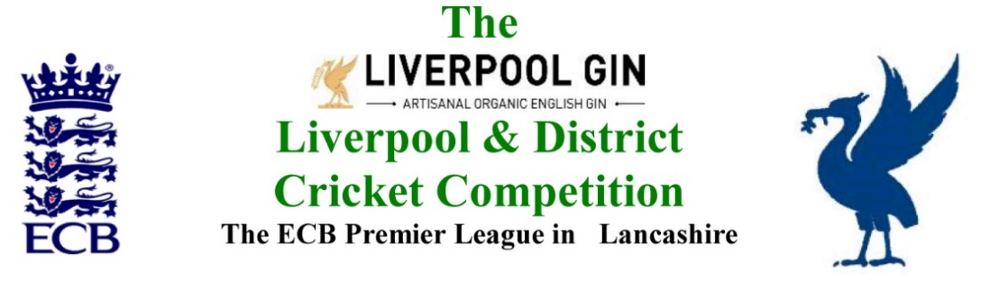
www.lpoolcomp.co.uk

The next meeting will be held at Bootle CC on Monday 25th September 2017 at 1.00pm.

DRAFT

Agenda to include

- Apologies

- Minutes

- Chairman's Remarks

- Club & Ground Chair’s Report

- Hon Treasurer’s Report

- Registration Sec's Report

- Fixture Sec's Report

- Cricket Chair’s Report

- Publicity & Sponsorship Chair’s Report

- Website matters

- Hon Secretary’s Report

- LCB / ECB Issues

- A.O.B.

- Date of Next Meetings

