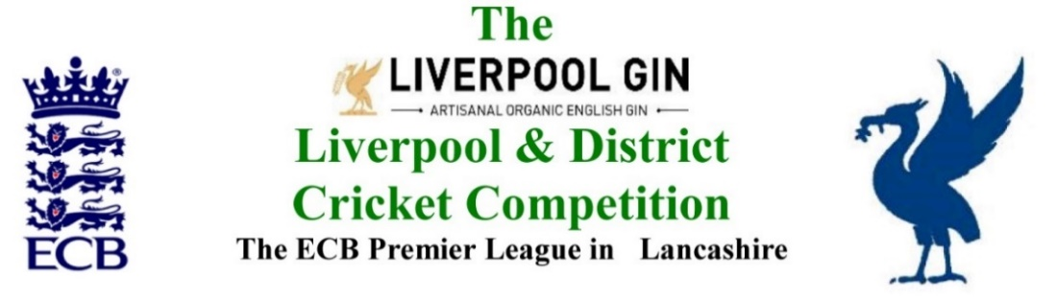
www.lpoolcomp.co.uk

M/C Meeting to be held at Bootle CC on Monday 28th Jan 2017 at 12.00 noon:

Agenda item | Recorded Minutes
Cup Draws | The four remaining Draws were carried out by the M/C closely and expertly supervised by EH.  ECB T20: Chrysalis: Embee: Leddy: http://www.lpoolcomp.co.uk/management_bulletins.php?id=3051
1.  Apologies: | - There were no apologies, all seven officials being present:  Eric Hadfield (President) John Williams (Chair) Chris Weston (Hon Sec); Rob Durand (1st & 2nd Team Fixture Secretary); Alan Bristow (Hon Treas); John Rotheram (Cricket Chair): Eddie Shiff (3rd XI Coordinator).
2.  Minutes: | - Signing of Previous Meetings  The minutes were available only in e-form at this meeting. The matter would be addressed at the next M/C meeting on the 26th February 2018  - Action Point Items  Were considered.  - Matters arising  These were to be taken en passant as they were covered by agenda items.
3. Chairman's Remarks | - Outcomes from AGM 2018  CW reported that the minutes had been posted on time and without difficulties. The feedback to CW from clubs had been limited but positive, the meeting had been described as businesslike and everyone had had their say.  AB noted that the total administration costs were down 8% on those three years ago.  - Running File AGM 2019  CW had started this rolling from AGM 2018. There were four to carry forward.  - Women’s Cricket Officer appointment  The advertisement had been placed: http://www.lpoolcomp.co.uk/news.php?id=3044  So far 1 formal application had been received – which looked very good - plus two verbal approaches.  The interview was likely to be the week after next.  - HE papers to ECB ACO Player’s New Law Training Seminars  The summary-paper of the bid was shown.  HE had indicated at the AGM that this MCUA/LDCC ECB ACO bid had been “accepted in full”.  It had been said that only one league in Lancashire seemed to be doing anything.  It was felt best now to leave this until HE could be contacted to find out more, the campaign process would be worked out in detail and then put into action.  - L&DCC Presentation Evening 2018 05/10/2018  M/C felt we had to reward successful teams. We needed an event of some kind, but we needed to change the format, date and the time of it. M/C suggested a Sunday at lunch time in October. This was discussed and agreed. Sunday the 7th October 2018 was agreed, it was two weeks after the end of the season, we could get all the preparation done by then.  CW would speak to Kate Fisher, JW would speak to Paul Allott.  - Indoor League 2018 and 2019  M/C formally agreed for the minutes to abandon the Indoor League in 2019. We had said we would give it one more go in 2018 having listened to the feedback from Cr Co and clubs and having made substantial changes for 2018 - none of which had helped. We now had 8 clubs in 2018 only 4 of which were L&DCC. The matter was discussed. It was far too expensive; our clubs were palpably not interested. No L&DCC Indoor League in 2019 was unanimously agreed. We would inform LCF and the clubs at the preseason meeting.  - PDP 2018  This was said to be going very well.  JW would send AB a list of the players and their clubs for the Statements of Account in April 2018.  - Handbook 2018  We intended to copy the format of Handbook 2017.  M/C wanted the files again to be sent to the printer before the end of February 2018  - JCL 23 01 18 L&DCC / S&D ACL  JW had circulated an email listing the outcomes following the SD ACL JCL meeting 23/01/18. The new JCL would be named the Liverpool Competition, Southport and District Junior Cricket League. (LCSDJCL)  There would be a JCL sub-committee, S&D ACL would have one representative on it, Tony Parker.  JCL contact numbers and regulations would need to go into the L&DCC 2018 Handbook. The regulations would stay exactly the same. The fixtures would go out separately.  New Clubs would be “Associate Junior Cricket League Members”.
4.  Club & Ground Chair’s Report | - Letters to promoted clubs  All the clubs had been written to, there was no change.  - ORT.  ORT had written EH/JW about (i) Ground Information re 2017 and planned Improvements 2018 requiring alterations to the fixtures, (ii) having another C&G Assessment in 2018 based on improvements already made in 2017 and (iii) entering another 3rd XI for 2018.  The matters were discussed  - Wigan  The state of the outfield was discussed, pictures were examined. EH would ring Wigan.
5.  Hon Treasurer’s Report | - Figures of Account Dec  As at 28/01/2018 were given.  - Income and Expenditure Dec  5.2.1 Expenditure  Not much was happening.  A bill from MCUA had been paid.  5.2.1 Income  There had been zero Income in December/January.  - Purchase of Balls 2018  The numbers required by M/C for Finals were discussed and actioned.  - Budget 2018  This updated budget was discussed in detail. A small loss of £390 was projected.
6. Registration Sec's Report | - Registrations Report RD update  Three registrations had taken place two others were in the pipeline.  JW noted that there had been no less than 35 notified-to-L&DCC player-movements but no actual registrations as yet. Reminders would be needed. Asserting that xyz had joined a club was not the same as that player being registered. M/C would post on this.  - South Liverpool CC  RD had spoken to them at the AGM.  - Sutton  Sutton’s player registrations were sorted.  - Ormskirk  A newly signed player had 1 week of a 3-week ban left to serve at his new club Ormskirk.  - Barbados players 2018:  Were discussed.  - Home Office  There had been no more feedback from ECB on premier league players and SVVs etc. in 2107. The  focus was said to be shifting to non-premier leagues in 2018 but nothing was confirmed.
7  Fixture Sec's Report | - 1st/2nd XI FS’ Report RD  Nothing had come through over the TBAs yet.  The Rainhill and Leigh were said to be wrong on play cricket . The wrong grid position seemed to have been used which was “odd”. This was being corrected.  - 3rd XIs League Coordinators Report: Release of Fixtures 2018  Most changes had been based on 3rd XIs and already dealt with  - 1st XI Ray Digman Cup  - 1st XI Ray Tyler Shield / Cup  - NatWest ECB T20  - 2nd XI Chester Cup  - 2nd XI Tittershill Shield/Cup  - Chrysalis Cup 2nd XI T20  - Mike Leddy Cup 3rd XI T40  - Embee Cup 3rd XI T20  - U16s/U21s  These competitions were now scrapped and would no longer appear in the 2018 agendas but the JCL U18 league and cup needed now to go in.  It was noted that Cheshire PCL was hosting the Indian touring Junior XI in 2018, New Brighton had one of the games.  - MCC Date/Game venue 2018  This was at SP CC on Tuesday 7th August 2018  Indoor League 2017/2018  Rep games 2018 U12/14/18/21/All Age  JW et al would do the draws and send them to CW for Handbook 2018  The U12s and U14s were to be handed back to LCF.  - ECB/LCB U19sT20 2018 No Central Entry portal 2018  - Brighton/Sussex touring side 2018  From Sun 15th to Fri 20th July:  Monday v Formby / Tues v Northern / Wed v Ormskirk/ Thur v L&DCC  The standard of the cricket was unknown but thought to be good i.e. Sussex 2s/Academy standard.  Andy Grice was running the Ainsdale and L&DCC games.
8.  Cricket Chair’s Report | - TCS and ECB new scoring update (2)  CW had posted on this twice  http://www.lpoolcomp.co.uk/management_bulletins.php?id=3031 http://www.lpoolcomp.co.uk/notice_board.php?id=3043  This system replaced TCS and ran on p-cs and lap tops  CCC scorers would be using it in 2018  ECB ACO would be running training evenings with one at Old Trafford tba
9. Publicity & Sponsorship Chair’s Report | - Items not previously covered under Item 3  We had no new sponsors.  EH and JW had a meeting planned with Bob Kelly from Halewood International.  - Articles were wanted for the website.
10. Website matters | - Gud Design for 2018  No report.
11.  Hon Secretary’s Report | - Printing costs  Were discussed
12.  LCB / ECB Issues | - MoU update  MoU 2017 had not been evaluated as usual with LCB in November 2017 as they made the transition to LCF. In the absence of that M/C had carried out a full assessment of it and for future discussion with LCF.  CW had drafted MoU 2018. Copies of the 6 new Priority Areas were provided to this meeting. This was work in progress.
13.  A.O.B. | - Paul Edwards  PE reported that the Echo was no longer to report on cricket and were releasing PE from his post. JW had attempted to speak to the sports Editor Dave Prentice several times without success. JW would write again and try to set up an early meeting with him.
14.  Date of Next Meeting | M/C Mon Jan 29th 2018 Bootle 1.00pm  S&D ACL Thur Feb 15th 2018 Bootle 7.00pm  Cr Co Mon Feb 19th 2018 Bootle 7.00pm  M/C Mon Feb 26th 2018 Bootle 1.00pm

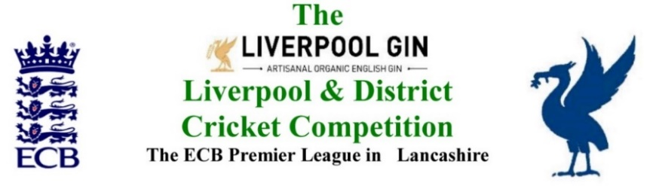
www.lpoolcomp.co.uk

The next meeting will be held at Bootle CC on Monday 26th February 2018 at 1.00 pm.

DRAFT

Agenda to include

- Apologies

- Minutes

- Chairman's Remarks

- Club & Ground Chair’s Report

- Hon Treasurer’s Report

- Registration Sec's Report

- Fixture Sec's Report

- Cricket Chair’s Report

- Publicity & Sponsorship Chair’s Report

- Website matters

- Hon Secretary’s Report

- LCB / ECB Issues

- A.O.B.

- Date of Next Meetings

