https://www.ecb.co.uk/about/science-and-medicine/concussion-in-cricket
Cricket
Concussion is a complex and potentially
Concussion education module

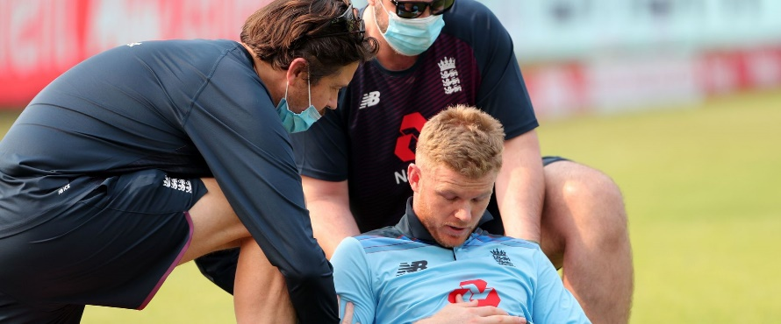

Concussion awareness is increasing in all sports from recreational to elite levels. Cricket is no different. Our online concussion education module is designed for both the professional and recreational game.

ACCESS THE MODULE

https://concussionlearning.ecb.co.uk/#/

Concussion resources and downloads
Find Out More

Coaches & Umpires
Find Out More

Healthcare Professionals
Find Out More

Players & Parents
Click To Download PDF

Return to play
More Info

Head injury advice
Any player with a suspected head injury must be monitored both on and off the field; the player should not leave the ground without being provided with head injury advice.
More Info

Eoin Morgan on concussion in cricket Eoin Morgan talks about his experience of dealing with concussion in cricket after receiving a blow to the helmet against Australia. 07 DECEMBER 2016

© ECB 2022

