In association with

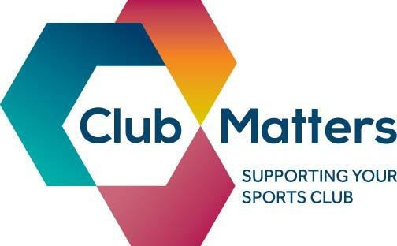

Understanding your Club Finances
Are you baffled by balance sheets or afraid of your accounts? We are running a
club finances workshop for all clubs that will cover:

Exercises to help you easily review and understand your club accounts

Developing and monitoring a budget

Ideas to help you improve your clubs cash flow
Methods to help with communicating your clubs finances effectively

Date: 8th May 2017 Time: 6pm -8pm Location: MSP, Unit 1 Dakota Business Park, Garston, L19 2QR

To book your place:
https://learn.sportenglandclubmatters.com

This workshop will give you the tools to tackle your clubs finances and help you make better decisions. Get your finances fit for the future.

@ClubMatters www.facebook.com/sportenglandclubmatters clubmatters@sportengland.org www.sportenglandclubmatters.com

Club Matter
s
Workshop

Developing a Business Plan
Do you have a dream for your club but struggle to make progress? We are running a business planning workshop for all clubs that will cover:

What is a business plan and why it’s important

A simple framework to develop your plan

Key players in developing a business plan
Top tips of what to include in your plan and common pitfalls to watch out for

Date: 3rd July 2017 Time: 6pm – 8pm

Location: MSP, Unit 1 Dakota Business Park, Garston, L19 2QR

To book your place:
https://learn.sportenglandclubmatters.com

This workshop will help you put together a simple yet effective business plan for your club to help you plan a brighter future and take real steps to reach your goals. Stop dreaming, start doing.

@ClubMatters www.facebook.com/sportenglandclubmatters clubmatters@sportengland.org www.sportenglandclubmatters.com

Understanding the options for club structures
It is important that sports clubs take the time to explore different club structures. We are running a club structures workshop for all clubs that will cover:

Importance of having the right club structure
Overview of different legal structures: unincorporated
& incorporation

Selecting the best status for your club- CASC or Charity

Getting to grips with gift aid

Date: 23rd August 2017 Time: 6pm- 8pm

Location: MSP, Unit 1 Dakota Business Park, Garston, L19 2QR

To book your place:
https://learn.sportenglandclubmatters.com

By attending this workshop you will gain an understanding of what structure is right for your club to enable success and stability.

@ClubMatters www.facebook.com/sportenglandclubmatters clubmatters@sportengland.org www.sportenglandclubmatters.com

Understanding the Tax Requirements for your Club People
Tax can be taxing but knowing your obligations is vital to avoid any nasty surprises. We are running a tax requirements for your club people workshop for all clubs that will cover:
The roles of

your club people and what this means for PAYE
requirements
Employment status - tests, guides & examples
Juggling
expenses for employees, clubs, individuals
Staying out in
front - recent developments
& practical next steps

Date: 13th September 2017 Time: 6pm – 8pm

Location: MSP, Unit 1 Dakota Business Park, Garston, L19 2QR

To book your place:
https://learn.sportenglandclubmatters.com

This workshop will help you understand more about the main PAYE and employment status issues affecting sports clubs and put you on track to take the pain out of PAYE.

@ClubMatters www.facebook.com/sportenglandclubmatters clubmatters@sportengland.org www.sportenglandclubmatters.com

T: 0151 728 1808
Teri Wainwright Workforce Support Officer

E: t.wainwright@merseysidesport.com W: www.merseysdiesport.com Address:
Merseyside Sports Foundation Unit 1, Dakota Business Park SkyHawk Avenue
Garston, Liverpool
Postcode: L19 2QR

