L&DCC
Umpires’ 2019 Season Report Summary
21 Apr 18 – 15 Sep 18 inc

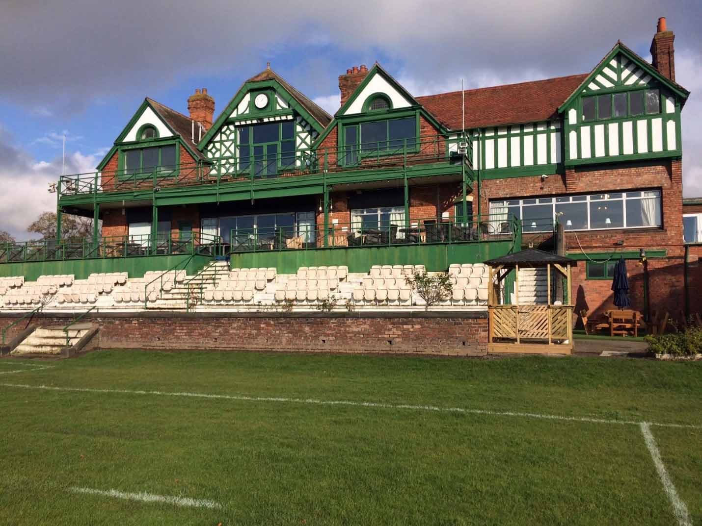

Prepared by: J S Hathaway – 22 Nov 19

1. Introduction

1.1 As part of the responsibilities for maintaining records in connection with the L&DCC Weekly Umpire Reports, the Management Committee (MC) require an end of season summary to examine the overall standard of facilities that are being offered by clubs, the pre-match administration that is completed by clubs within the League and an overall assessment of the spirit of cricket.

1.2 The data that is contained within this report is based on the following template that is completed by all umpires at the conclusion of league matches:

L&DCC UMPIRES’ REPORT
Please forward to [jim.hathaway@gbpartnerships.co.uk] within 5 days following match
L&DCC Premier Div | X | L&DCC Div 1 |  | L&DCC Div 2 |  | Other
Insert X in appropiate box or type of match in Other, eg ‘Ray Digman’
Match |  |  |  | v |  |  |  |  | on
Umpire’s names |  | Umpire 1 |  |  |  |  |  | Umpire 2
Answer questions below with Y, N, or number
1 | Team sheets before toss ? (Home) |  | Y/N |  |  |  | 14 | Scoreboard operated effectively? * |  |  | 0/1/2/3/4/5
2 | Team sheets before toss? (Away) |  | Y/N |  |  |  | 15 | Scorers signals clearly visible? * |  |  | 0/1/2/3/4/5
3 | Payment before match? (Home) |  | Y/N |  |  |  | 16 | Umpires’ room lockable AND key available? |  |  | Y/N
4 | Payment before match? (Away) |  | Y/N |  |  |  | 17 | Umpires’ room clean, tidy & no storage? |  |  | 0/1/2/3/4/5
5 | Scorer? (Home side) |  | Y/N |  |  |  | 18 | Clock working & showing correct time? |  |  | Y/N
6 | Scorer? (Away side) |  | Y/N |  |  |  | 19 | Bell accessible & audible to players & spectators? |  |  | Y/N
7 | Ground requirements before and during the match – previous repairs, dry pitch, correct markings and stump positions, screens pre-match, marking & rolling at interval, drying equipment eg sawdust, covering during match as necessary. (1 mark min. lost per failing) |  | 0/1/2/3/4/5  6/7/8/9/10 |  |  |  | 20 | Hospitality – teas ready when needed? * |  |  | Y/N
8a | ECB/PQS pitch rating – Even bounce |  | 0/1/2/3/4/5 |  |  |  | 21 | Hospitality - quality of teas? |  |  | 0/1/2/3/4/5

8b | ECB/PQS pitch rating – Seam movement | 0/1/2/3/4/5 |  | 22 | Home team respect for Opponents | 0/1/2/3/4/5
8c | ECB/PQS pitch rating – Carry and bounce | 0/1/2/3/4/5 |  | 24 | Home team respect for Umpires | 0/1/2/3/4/5
8d | ECB/PQS pitch rating – Turn | 0/1/2/3/4/5 |  | 25 | Away team respect for Opponents | 0/1/2/3/4/5
9 | Outfield – ECB-appearance/ grass length? | 0/1/2/3/4/5 |  | 26 | Away team respect for Umpires | 0/1/2/3/4/5
10 | Outfield – ECB-unevenness? | 0/1/2/3/4/5 |  | 27 | Home captain - team control | 0/1/2/3/4/5
11 | Boundary – ECB-markings? | 0/1/2/3/4/5 |  | 28 | Home captain – cooperation with umpires | 0/1/2/3/4/5
12 | Surrounds – number of minutes lost for ‘lost’ or balls out of ground. |  |  | 29 | Away captain - team control | 0/1/2/3/4/5
13 | Surrounds – maintenance condition? | 0/1/2/3/4/5 |  | 30 | Away captain – cooperation with umpires | 0/1/2/3/4/5
Comments: Please include details of any Level 1 warnings given under Law 42; and where general behaviour by a team is unacceptable but falls short of any action under Law 42. |  |  |  | Players reported  Name: Club: H/A Level of Offence  One/Two  On-field Sanction?

1.3 The template is a combination of numerical and Y/N scores and this report will examine several scores, for each club and division, that attract a numerical score. The elements that are examined in this paper are as follows:

1 – Overall Pitch Marks

2 – Total Minutes Lost (Season) – Retrieving Lost Balls

3 – Average Minutes Lost (Per Match) – Retrieving Lost Balls

4 – Home Team – Respect for Opponents & Umpires

5 – Away Team – Respect5 for Opponents & Umpires

6 – Home Captain – Team Control & Cooperation with Umpires

7 – Away Captain – Team Control & Cooperation with Umpires

2. Pitch Marks

2.1 Pitches are assessed on 4 elements: Even Bounce, Seam Movement, Carry & Bounce and Turn. From these 4 elements, the totals are taken and the final average scores, per club, can be seen below:
Premier Division
Division 1
Division 2

3. Total Minutes Lost For Retrieving Balls, Per Club – 2019

3.1 Question 12 of the Umpire’s Report requests that the above detail is submitted for every match. The following information shows how many minutes were lost by each club across the 2019 season as well as the average number of minutes per match:
Premier Division
Division 1
Division 2

4. Home Team Respect for Opponents & Umpires

4.1 In accordance with the Spirit of Cricket initiative, the following information shows how home teams conducted themselves in terms of respecting opponents and umpires:
Premier Division
Division 1
Division 2

5. Away Team Respect for Opponents & Umpires

5.1 In accordance with the Spirit of Cricket initiative, the following information shows how away teams conducted themselves in terms of respecting opponents and umpires:
Premier Division
Division 1
Division 2

6. Home Team Captain - Team Control & Cooperation with Umpires

6.1 In accordance with the Spirit of Cricket initiative, the following information shows how home team captains maintained control over their teams and cooperated with umpires:
Premier Division
Division 1
Division 2

7. Away Team Captain - Team Control & Cooperation with Umpires

7.1 In accordance with the Spirit of Cricket initiative, the following information shows how away team captains maintained control over their teams and cooperated with umpires:
Premier Division
Division 1
Division 2

8. Conclusion

8.1 The above information is presented in the form of an executive summary that is based on extensive records for each club and division that covers the 2019 season.

8.2 Should anyone require any further information, or clarification on any points please contact me on: Jim.hathaway@gbpartnerships.co.uk

