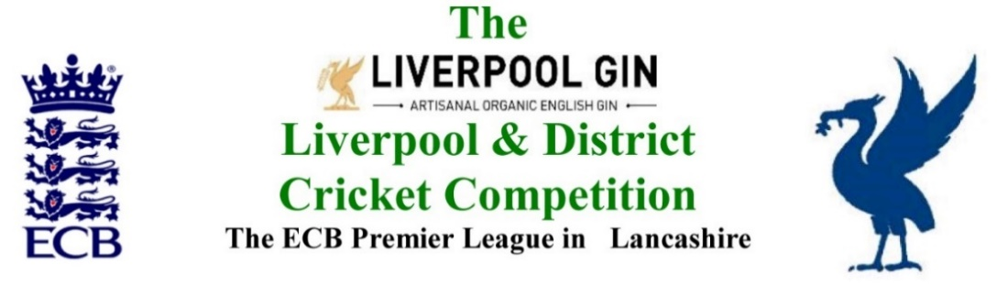
www.lpoolcomp.co.uk

M/C Meeting held at Bootle CC on Tuesday 28th August 2018 at 6.00 pm:

Agenda item | Recorded Minutes
1.  Apologies:  12.52 pm | - AB gave his apologies, he had sent a full report.  All were otherwise present: Eric Hadfield (President); John Williams (Chair); Chris Weston (Hon Sec); Rob Durand (1st & 2nd Team Fixture Secretary); Jim Hathaway (Club and Ground Chair); Eddie Shiff (3rd XI Co-Ordinator)
2.  Minutes: | - Signing of Previous Meetings  The (acting) Chair EH signed the July 2018 set of M/C minutes as a true and accurate record of the meeting.  - Action Point Items  The Action Points were considered briefly as set out below and picked up in detail under agenda items as appropriate and necessary.  - Matters arising.  These were to be taken en passant as they were covered by agenda items.
3. Chairman's Remarks | - LCF meeting BCL and GM CL Ray Taylor  There was a posting on the website from LCF that covered this.  - Bootle and Ormskirk 2s Donation to Opening Up.  M/C needed to check that these donations had actually been made.  - Women’s and Girls Cricket  CW was to write to Paul Bate inviting him to the next meeting. Things were going well.  - MCUA  M/C was to have a post-season meeting with MCUA.  - Spring View CC/Jon Broad meeting M/C 04/09/19 Bootle CC 7.00pm  There were two reasons for Spring View’s appearance.  - M/C correspondence had been copied to Phil Lovegreen’s and the material was now on his website.  - The Official Spring View Twitter feed.  Both occurrences breached 1.4 P81 of the disciplinary Code.  - Reversing Cup fixtures because of GWL 2.6 P57  This was now in the CW AGM 2019 running file.  - SoC mark deductions >0.1  It had been agreed that the second SoC tranche marks would be adjusted on the same basis as tranche one i.e. with disciplinary adjustments at - 0.1 each.  A training point for MCUA umpires in 2019 was needed over equipment abuse as a player left the field. Some umpires watched for this, others did not, there were inconsistencies between umpires here. Some players were getting bans others were not.  - L&DCC Presentation Afternoon 07/10/2018  CW was to use the material in Appendix 3 to draft something for the website and then send it to JW for posting.  The LD-SD-JL presentations were to be added. The numbers would go up. The presentation was to take place in the Sports Hall area to fit everyone in.  - End of season meetings MYC JL  JW was sorting a date for this.  - End of season Consultation on 3rd XIs 2019  We would have a consultation via a questionnaire that JW would draft, then we would have  open meetings. The questionnaire would be e-circulated. The open meetings would be in the round with clubs working together on separate tables.  The time-frame would be the week commencing 17th Sept with the open forum at Firwood-Bootle CC on the 8th Oct.  - Sponsorship LG 2018  This was ongoing .
4.  Club & Ground Chair’s Report | - JH Report  JH reported that the C&G inspections for 2018 were complete. The reports were looking quite a picture, everybody was showing improvements.  Umpires marks were coming in, we were closing in on the end of the season.  CW reminded about the need to provide ECB with their final tranche of SoC and pitch marks.  - Norley Hall report update  EH would write to Norley Hall CC – who had finished top of the premier division of the S&D ACL and who stood to be promoted if they met the L&DCC criteria - with a list of things that they needed to do for C&G based on their recent inspection.  - Using the C&G data going forward  We would return to this subject later in the year. All options were open.
5.  Hon Treasurer’s Report | - Figures of Account August  Were given  - Cost of Teas and umpires for Echo Cup 2018  AB was asked to pay the Firwood-Bootle CC invoice. Fines so far in 2018  EH reported that fines were at circa £5k and were expected to climb to £7k by the end of the season.
6.  Registration Sec's Report | See also Cricket Committee report  - Registrations Report RD update  RD reported that there were no registrations outstanding, only 3rd XI players continued to be registered.  - Cat 2s 2018 sub proing from L&DCC 6.3 P72 after 31/07  A number of these continued to take place.  - Dual Registrations  The M/C meeting with the S&D ACL on the 13th Sept at Firwood-Bootle CC at 7.00pm was referred to.
7.  Fixture Sec's Report | See Cricket Committee  Ormskirk Appeal Ormskirk 2s v Ainsdale 2s no agreement rearranged game awarded to Ainsdale by Cr Co  The matter was discussed again. M/C, we should attempt to get them to play but it was 5 points each if they did not.  - 1st/2nd XI FS’ Report RD  - Age group player over bowled Newton-le-Willows CC - 1st XI Vs Ainsdale CC - 1st XI  M/C had written to MCUA to raise this with the two umpires.  - SPT and Prestatyn conceded game  SPT had put in a bill for loss of income as well as for teas. The matter was discussed.  - Rainhill 2s v Highfield 2s 01/09/18 SoC re team selection  There were no breaches of regulations.  To M/C it was a SoC issue. The matter was discussed at length.  M/C was to send a letter to Rainhill, noting that SoC was breached last week, action would be taken if there was repetition.  - 3rd XIs League Coordinators Report  Liverpool 3s v SP 4s 25 08 18.  Liverpool CC had not behaved unreasonably, 5 points each.  - 1st XI Ray Digman Cup  The Northern/Firwood-Bootle CC semi was 09/09/18, the Final 16/09/18.  - 1st XI Ray Tyler Shield / Cup  - NatWest ECB T20  - 2nd XI Chester Cup  - 2nd XI Tittershill Shield/Cup  - Chrysalis Cup 2nd XI T20  - Mike Leddy Cup 3rd XI T40  - Embee Cup 3rd XI T20  This was re-arranged to 22/09/18 at NleW  RD/ES presenting  - MCC Game 07/08/2018  - Rep games 2018 U12/14/18/21/All Age  These were all finished.  - ECB/LCB U19sT20 2018  There was no report.  - Brighton/Sussex touring side 2018  - Echo Cup  - LC-SD- JL  See previous Agenda item 3.  - Stephen Croft Testimonial Game 2018
8.  Cricket Chair’s Report | - Cr Co outcomes  There was no report.  - Medals  The junior trophies were to come from S&D ACL  JW would mail a list of the LC-SD-JL ones to JR for Lanes to engrave.
9.  Publicity & Sponsorship Chair’s Report | - PoM ICON presentations  July’s data had been sent promptly to ICON.  RD noted that data for Cr Co and PoM Aug/Sept 2018 and Players of the Year 2018 was going to be tight given the dates.  - LG Sponsorship 2019  See previous 3.13
10. Website matters | RD had changed the Formby/Bootle result on play-cricket after it had been mangled by a “one-off” and inadvertent second log-on .
11.  Hon Secretary’s Report | - Dates of meetings going forward  Were as recorded in Appendices 5-7  - Trophies  CW and ES would liaise over the weekend. ES would ring and collect from those still outstanding.  - ECB Cricket Survey 2018  This was now closed.  - ECB Umpires survey  This was also closed. It was hoped that the survey would be useful, it was looking for responses from very particular types of umpire.  - Indoor league LDCC and LCF Burscough as Rep team 2018  Was noted  ORT CC had asked about this winter’s competition.  We had agreed to have a Finals day for any that wanted it.
12.  LCF/LCB | - End of Season MoU meeting with L&DCC  Was noted
13.  A.O.B. | - Alder CC wanted to return to the 3rd XI Saturday Division 1 competition in 2019. This was agreed. It was good news.  ORT CC also wanted a team there too, this was also agreed and was more good news.  South Liverpool CC also wanted a team there too, moving from Sunday, this was again agreed and was even more good news  This gave 14 teams in that Division.  - RD noted that when Alder 3s withdrew 1 or 2 of the games had been conceded against them. EH was aware of this, Alder would not be fined for these games.
14.  Date of Next Meetings  6.57pm | See Appendices 5-7

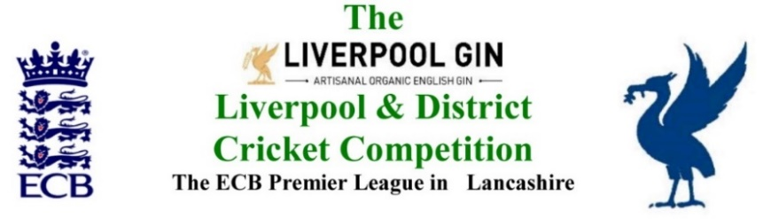
www.lpoolcomp.co.uk

The next meeting will be held at Bootle CC on Monday 24^{h} September 2018 at 1.00 pm.

DRAFT

Agenda to include

- Apologies

- Minutes

- Chairman's Remarks

- Women’s and Girls Cricket

- Club & Ground Chair’s Report

- Hon Treasurer’s Report

- Registration Sec's Report

- Fixture Sec's Report

- Cricket Chair’s Report

- Publicity & Sponsorship Chair’s Report

- Website matters

- Hon Secretary’s Report

- LCB / ECB Issues

- A.O.B.

- Date of Next Meetings

