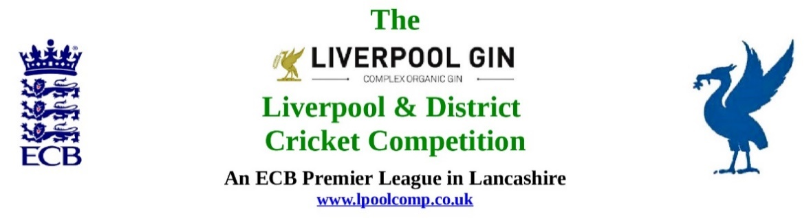

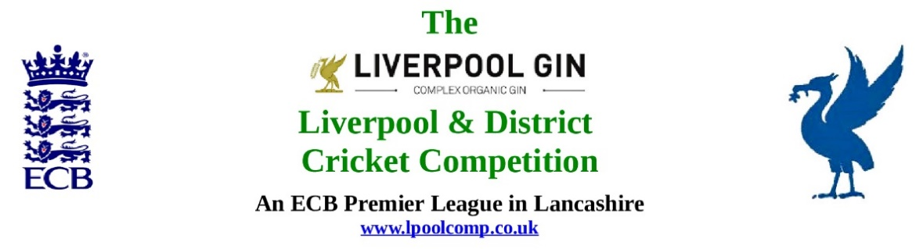

Pre-M/C Finance Meeting to be held at Firwood-Bootle CC on Monday 28th October 2019

Present:

Seven M/C officials were present:

Eric Hadfield EH (President); John Williams JW (Chair); Chris Weston CW (Sec); Peter Fleetwood PF (Treas); Rob Durand RD (1st & 2nd XI Fixture Secretary; Registration Secretary; Cups sub-Co Chair); Jim Hathaway JH (Club & Ground Chair); Neil Crew (JL sub-Co Chair); John Rotheram (ex officio).

PF was looking to put in place a budget that delivered our minimum requirements without dipping into our reserves.

A digital projector was used to show a series of Excel .xls spreadsheets constructed by PF to illustrate in real time how various models for the L&DCC budget could be constructed.

The 2019 position was shown for reference.

A lengthy discussion took place. It was unanimously agreed that consideration would be given to making proposals to AGM 2020 to balance our books in changing times..

PF would consolidate a model that would give an overall cost-neutral core and circulate it to M/C.

M/C Meeting held at Bootle CC on Monday 28th October 2019 at 1.00pm

Agenda item | Recorded Minutes
1.  Apologies:  1.07 pm | - Apologies  Eddie Shiff ES (Third XIs sub-Co Chair); Paul Bate (W&G sub-Co Chair);  Seven M/C officials and one ex officio official were present: Eric Hadfield EH (President); John Williams JW (Chair); Chris Weston CW (Sec); Peter Fleetwood PF (Treas); Rob Durand RD (1st & 2nd XI Fixture Secretary; Registration Secretary; Cups sub-Co Chair); Jim Hathaway JH (Club & Ground Chair); Neil Crew (JL sub-Co Chair); John Rotheram (ex officio).
2.  Minutes: | - Minutes of previous meetings:  The minutes from the meeting 30/09/2019 had been circulated without comment.  - Signing of previous Minutes:  The minutes from the meeting 30/09/19 were signed by the Chair as a full and accurate record of that meeting.  - Action Point Items from meeting 30/09/19:  Were again considered en passant.
3.  Chairman's Remarks | - Welcome:  JW repeated his welcome to everyone, we had a good attendance at this important meeting.  - Mike Dixon  - For the benefit of the minutes JW made clear that, as notified to JW, CW and EH and now circulated to the whole M/C on 18/10/2019 Mike Dixon had actioned a “Letter Before Action pursuant to the Pre Action Protocol for Media and Communications Claims (replacing the Pre Action Protocol for Defamation Claims) and Practice Direction - Pre Action Conduct and Protocols  - The notification was a Pre-Action Protocol Before Action. We had to wait for our lawyers to read into all the papers they had requested and which we had supplied and then to be guided by them.  - The matter was discussed in detail.  - EoS 08/10/19 outcomes  There were no known issues arising from this meeting.  - LCOF (1-4) outcome of meetings 2019.  The excellent RD LCOF raw data summary had been circulated; RD carefully explained the meaning of the listings. We needed a summary for the 3rd XI EoS meeting now on 12th Nov at Alder CC at 7.30 pm.  - S&D ACL and Burscough 17/10/19  The previous M/C meeting and the Feeder League meeting were referred to. As instructed CW had written formally to Burscough releasing them from the L&DCC as they had requested. The changing nature of this matter was discussed. M/C unanimously agreed to take them back if that was what they wanted.  - ECB End of Season data 2019  CW had sent all the data and also copied it to M/C.  CW and JW were going to a North West Premier Leagues meeting with ECB in Wigan on the 28th November.  - Changes to L&DCC Eligibility of Players 2020  There was no new information.  ECB had not replied in respect of the 2020 Categorisation of an ICC player  - ECB and Professional Leagues and Category 3 notifications  ECB had written to “Designated Professional Leagues” in Lancs about overseas players going forward. (Bolton, Greater Manchester, Lancs League etc. We had not been written to as we were a premier league and as such we supplied ECB with full details of our Category 3 players.
4.  Hon Treasurer’s Report | - Figures of Account Sept:  Detailed figures were given.  - Movement Current/Deposit Account  Detailed figures were given:  - Income Sept:  Detailed figures were given:  - Expenditure Sept:  Detailed figures were given of Major Expense Items  - Auditing of Accounts 2019  The accounts had been sent to our auditors Messrs JVSA: Chartered Accountants, Ormskirk.  - PF Notes re Oct  See Pre-Meeting Financial Meeting.  - Fines to date  PF commented on how little time he had had to get the statements out to the clubs given the lateness of the notification to him prior to the End of Season Meeting.  Season 2019 had finished a week later than had been usual - which telescoped the time left for basic administration.  CW was happy to schedule the Oct “main” EoS meeting a week later in 2020.
5.0.  sub-Committees: | Sub Committees are “agenderised” in M/C meetings in alphabetic, monthly rolling order.
5.1  Cup Competitions sub-Committee | 5.1.0 Sub-Co Report  - All results were on the Roll of Honour: http://www.lpoolcomp.co.uk/news.php?id=3399  - JW noted that feedback from the four “LCOFs” had been clear, 1st XI Cup Competitions on Saturdays were not popular. The issue of the length of the season at 22 or 23 weekends had also cropped up. We could switch back to Cups on Sundays only and start a week later in 2020 instead, giving a 22-week season. http://www.lpoolcomp.co.uk/news.php?id=3414 We would also not schedule Digman/Tyler on the same Sunday to relieve pressure on umpire numbers. This was unanimously agreed.  - The entries for the National Club T40 2020 had been completed and sent to ECB competitions by CW. There were 7 entries this year http://www.lpoolcomp.co.uk/management_bulletins.php?id=3380  - The entries for the LCK KO 2020 had not been completed and sent to LCF. There were 4 entries this year from each of the “top” LCF leagues but nothing in detail had been heard from LCF since their generic letter of 18th Sept 2019 about entries or about the new “plate” competition to run alongside the main competition in 2020. L&DCC 2020 entries would be Bootle/Ormskirk/Northern/and then either New Brighton or Formby – it depended if New Brighton again preferred to play in the Cheshire KO in 2020.  - 1st XI Ray Digman Cup  - 1st XI Ray Tyler Shield/Cup:  - NatWest ECB T20:  - Echo Cup:  - 2nd XI Chester Cup:  - 2nd XI Tittershill Shield/Cup:  - Chrysalis Cup 2nd XI T20:  - Mike Leddy Cup 3rd XI T40:  - Embee Cup 3rd XI T20  - Chrysalis Cup 2nd XI T20:  - Mike Leddy Cup 3rd XI T40:  - Embee Cup 3rd XI T20:
Disciplinary sub-Committee: | - Sub-Co Report  A full report was given
Junior League sub-Committee: | - Sub Co Report  Neil C advised that there was little more to report on the Liverpool Competition-Southport District-Junior Leagues ( LC-SD-JLs), relative to September.  - Neil C had set up a meeting with MYC JL. M/C wished them all well.  - Neil C had retrieved another U11 shield.  - There had been only 10 respondents to the Neil C End of Season Survey, this was slightly disappointing. CW noted it was a better pro rata return than the Comp wide one on the Annual Dinner!  - JW invited Neil C to “pop in” anytime to the PDP when it commenced in January 2020 http://www.lpoolcomp.co.uk/news.php?id=3410 , it might be useful.  - JW had secured what looked to be a very good deal for PDP at St Bedes in 2020.
Third XIs sub-Committee: | - Sub Co Report  There was no report.  LCOF output would be critical here.
5.5  Women’s and Girls sub-Committee: | - Sub Co Report  CW read out PBa’s report which had also been circulated
5.6  Club and Ground sub-Committee: | - Sub-Co report  The ECB required summaries had been collated and sent in.  The Fair Play marks were exceptional.  The return of the Captains marks was disappointing, they produced a distorted picture.  - C&G inspections  All club C&G data was now “in”.  An executive summary to M/C would follow  JW would get out a report to each club based on the data
6.  First and Second XI Leagues: | - RD  There was no report  - PoM and PoY 2020  M/C felt we should ask Sam Holt from ICON to come to this committee and try to set this up for the next M/C meeting 25/11/19
7.  Registration Sec's Report: | - Registrations Report:  Some were coming in - but most seemed to be on social media not on registration forms.
8.  Management Committee Competitions | - MCC 2020: 04/08/2020 FB CC  This was now organised and confirmed with MCC.  - Rep games 2020:  The Senior Lancs Inter League was on the 2nd Bank Holiday Monday in May, it would be a T20 2 semis and a final between 4 leagues (Bolton, GM, Ribblesdale and L&DCC), we were playing Ribblesdale. We had to supply 1 umpire.  The U18s played 3 games each in May, June and July. It would be run as a league by Brian Woodhead and Bob Hinchliffe, mirroring the interleague system.  An U14s boys meeting was to take place. L&DCC would possibly continue to run these competitions going forward but only on the basis of a financial contribution from LCF e.g. to pay travel costs.  - Age Group Games U12/14/18/21/All Age: 2020  JW rehearsed the history of the L&DCC’s involvement with the U12/14s.  - ECB/LCF U19sT20 2020:  There was no information, it looked as though it might not be running in 2020.  - Brighton/Sussex touring side 2020:Report  We needed a reply from Cheshire for 2020
9.  Hon Secretary’s Report: | - Dates of Meetings 2020  The matter was discussed. We used the last week of the month as it maximised M/C members availability. When we had used the first week of the month availability had been poorer.  It was agreed that CW would construct and circulate a new calendar full of dates for 2020 based on the 2019 pattern of meetings.  - EoS 3rd XI meeting 12/11/19 Alder CC  http://www.lpoolcomp.co.uk/notice_board.php?id=3406 This matter had already been discussed partially earlier in the meeting under 3.4. LCOF output would be vital here. The RD summary must have taken hours of work and was excellent.  The published agenda would adapt to what was needed on the night.  - Northern CC LCF Club of the Year  CW was to write to N CC to congratulate them!
10. Website matters | - Gud Design for 2020:  CW had obtained written confirmation from Gud Design that “the Article” Mike Dixon was acting on was never on the lpoolcomp website – it was on Lovegreen’s.  - Play-Cricket  RD confirmed that the usual p-c updates and releases would be taking place during the winter.
11.  LCF/ECB Issues: | - LCF Update  See 8.2.  The next MoU meeting MoU 2019 (3) was scheduled for 14th November 2019 at the Thistle/Mercure Hotel Haydock at 2.00pm  - ECB Update:  CW and JW would be attending the next ECB Premier Leagues regional meeting on Thursday 28th November 2019, 4.30pm at the DW Stadium, Loire Drive, Robin Park, Wigan, WN5 0UH.  At this meeting ECB intended to share the progress made on the future funding arrangement between ECB and Premier Leagues 2020 to 2024. The meeting would also give ECB an opportunity to review the 2019 season and answer any questions we had in advance of 2020.
12.  A.O.B. | There were no items of Any Other Business

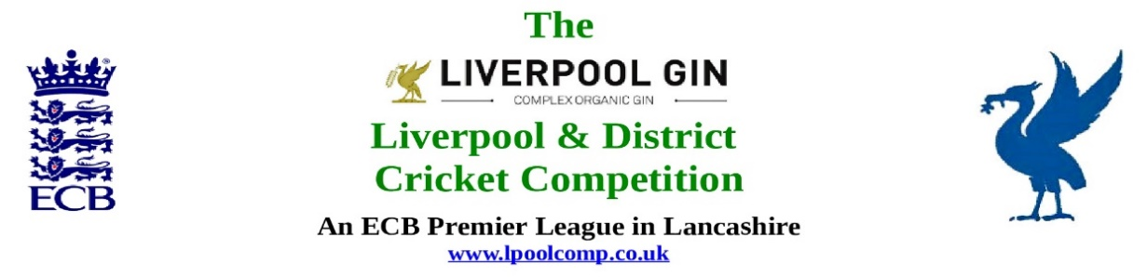

M/C Meeting to be held at Bootle CC on Monday 25th November 2019 at 1.00pm

- Apologies:  - Apologies  - Minutes:  - Minutes of previous meeting:  - Signing of previous Minutes:  - Action Point Items from previous meeting:  - Matters arising from previous meeting:  - Chairman's Remarks:  - Welcome:  - Hon Treasurer’s Report:  - Figures of Account Nov:  - Income Nov:  - Expenditure Nov:  - Notes  - sub-Committees:  - Club and Ground sub-Committee:  - Sub-Co report  - Disciplinary sub-Committee:  - Sub-Co Report  - Junior League sub-Committee:  - Sub Co Report  - Third XIs sub-Committee:  - Sub-Co Report  - Women’s and Girls sub-Committee:  - Sub-Co report | - Cup Competitions sub-Committee:  - Sub-Co Report  - 1st XI Ray Digman Cup  - 1st XI Ray Tyler Shield/Cup:  - NatWest ECB T20:  - Echo Cup:  - 2nd XI Chester Cup:  - 2nd XI Tittershill Shield/Cup:  - Chrysalis Cup 2nd XI T20:  - Mike Leddy Cup 3rd XI T40:  - Embee Cup 3rd XI T20  - Chrysalis Cup 2nd XI T20:  - Mike Leddy Cup 3rd XI T40:  - Embee Cup 3rd XI T20:  - First and Second XI Leagues:  - RD  - Registration Sec's Report:  - Registrations Report:  - Management Committee Competitions  - MCC 2019: 04/08/2020  - Rep games 2020:  - Age Group Games U12/14/18/21/All Age:  - ECB/LCF U19sT20 2020:  - Brighton/Sussex touring side 2020:  - Hon Secretary’s Report:  - Website matters:  - Gud Design for 2020:  - Play-Cricket  - LCF / ECB Issues:  - LCF Update  - ECB Update:  - A.O.B.:  - Date of Next Meetings:  See Appendix 1

